**BANK LOAN REPORT QUERY DOCUMENT**

1. **BANK LOAN REPORT | SUMMARY**

**KPIs:**

**Total Loan Applications**

**Calculate Total Applications received**





**MTD Loan Applications**

**Calculate MTD Total Loan Applications**





**MTD Loan Applications**

**Calculate Month to Date Total Loan Applications**





**Previous MTD (PMTD) Loan Applications**

**Calculate Previous Month to Date Total Loan Applications**





**Month on Month Total Loan Applications**

**Calculate MOM Total Loan Applications**

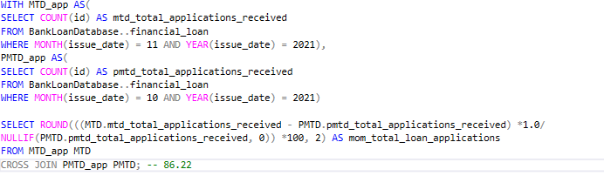



**Total Funded Amount**

**Calculate the Total Funded Amount**





**MTD Total Funded Amount**

**Calculate the MTD Total Funded Amount**





**PMTD Funded Amount**

**Calculate the PMTD Total Funded Amount**



**Month on Month Total Funded Amount**

**Calculate MOM Total Funded Amount**



**Total Amount Received**

**Calculate the Total Amount Received**





**MTD Total Amount Received**

**Calculate the MTD Total Amount Received**





**PMTD Total Amount Received**

**Calculate the PMTD Total Amount Received**





**Month on Month Total Amount Received**

**Calculate MOM Total Amount Received**

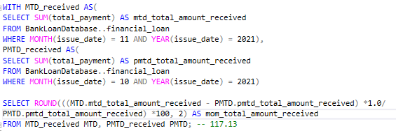



**Average Interest Rate**

**Calculate the Average Interest Rate**





**MTD Average Interest Rate**

**Calculate the MTD Average Interest Rate**





**PMTD Average Interest Rate**

**Calculate the PMTD Average Interest Rate**





**Month on Month Average Interest Rate**

**Calculate MOM Average Interest Rate**

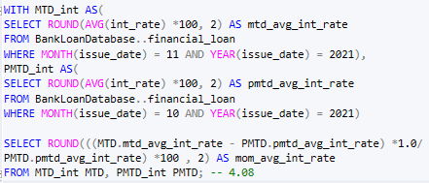



**Average Debt to Income Ratio (DTI)**

**Calculate the Average Debt to Income Ratio (DTI)**





**MTD Average DTI**

**Calculate the MTD Average Debt to Income Ratio (DTI)**





**PMTD Average DTI**

**Calculate the PMTD Average Interest Rate (DTI)**





**Month on Month Average DTI**

**Calculate MOM Total Amount Received (DTI)**

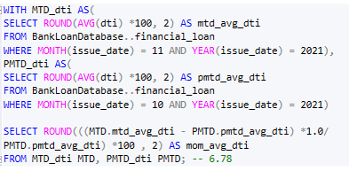



**GOOD LOAN ISSUED:**

**Good Loan Percentage**

**Calculate the Good Loan Application Percentage**

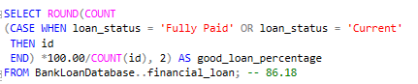



**Good Loan Applications**

**Calculate Number of Good Loan Applications**





**Good Loan Funded Amount**

**Calculate Number of Good Loan Funded Amount**





**Good Loan Amount Received**

**Calculate Number of Good Loan Total Received Amount**





**BAD LOAN ISSUED:**

**Bad Loan Percentage**

**Calculate the Bad Loan Application Percentage**

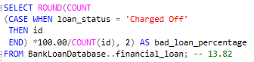



**Bad Loan Applications**

**Calculate Number of Bad Loan Applications**





**Bad Loan Funded Amount**

**Calculate Number of Bad Loan Funded Amount**





**Bad Loan Amount Received**

**Calculate Number of Bad Loan Total Received Amount**





**LOAN STATUS:**

**Calculating the Loan Count, Total Amount Received, Total Funded Amount, Interest Rate, DTI based on Loan Status**

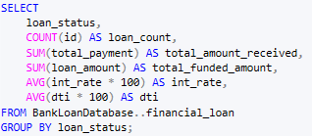

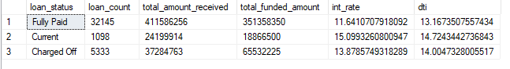

**MTD Loan Status**

**Calculating the MTD Total Amount Received and MTD Total Funded Amount based on Loan Status**

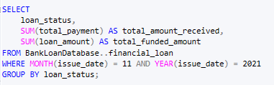

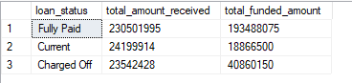

1. **BANK LOAN REPORT | OVERVIEW**

**MONTH:**

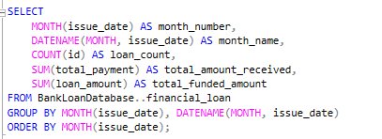

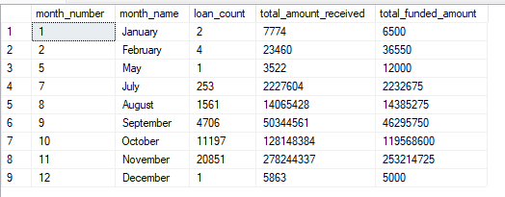

**STATE:**

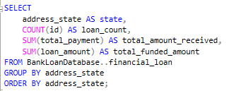

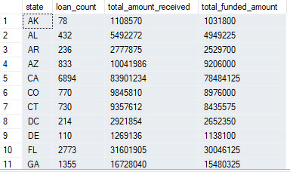

**TERM:**

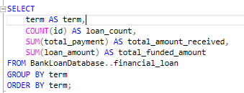

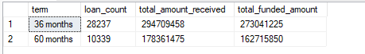

**EMPLOYEE LENGTH:**

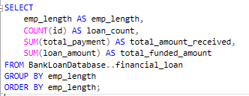

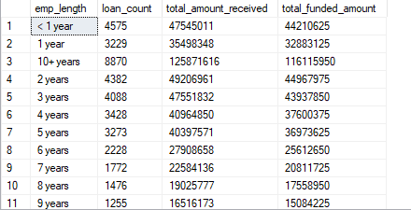

**LOAN PURPOSE:**

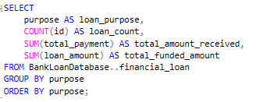

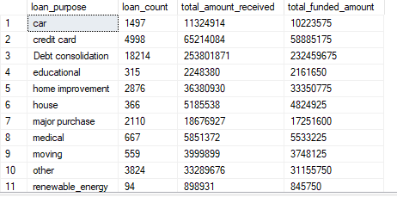

**HOME OWNERSHIP:**

